Data Agent Assignment

- Log into Databricks then locate Genie Agents tab:

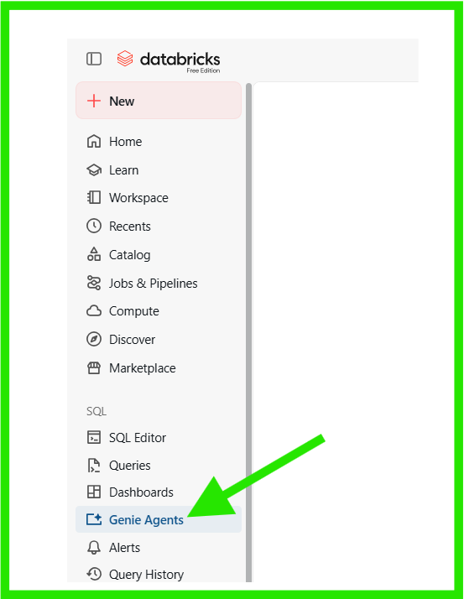

- Select New button to give an option to select the data set (IT Asset Management dataset) in this case:
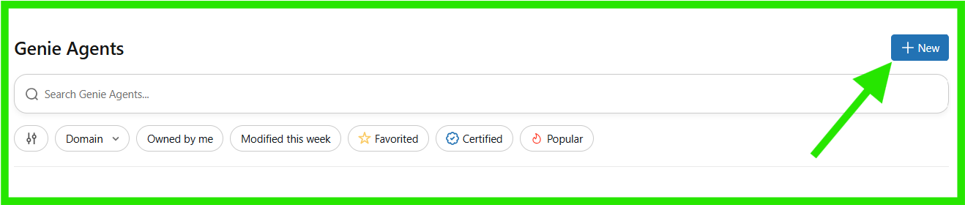

- You’ll be presented with multiple datasets upon which you select the one to use for Agent creation then select the ‘Create’ button underneath.
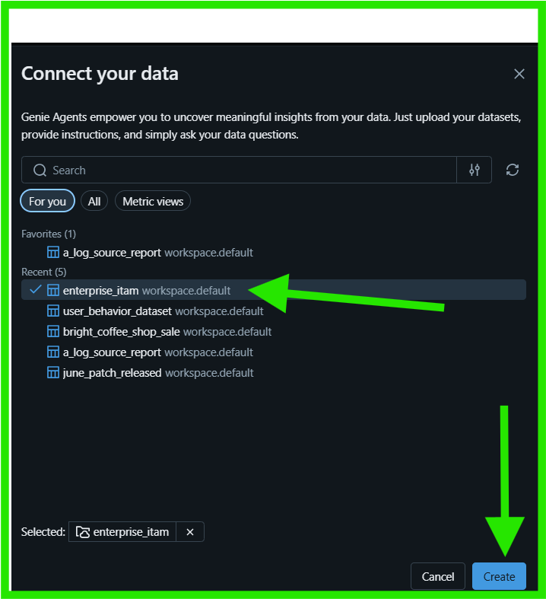

- Navigate top right to the configure button:
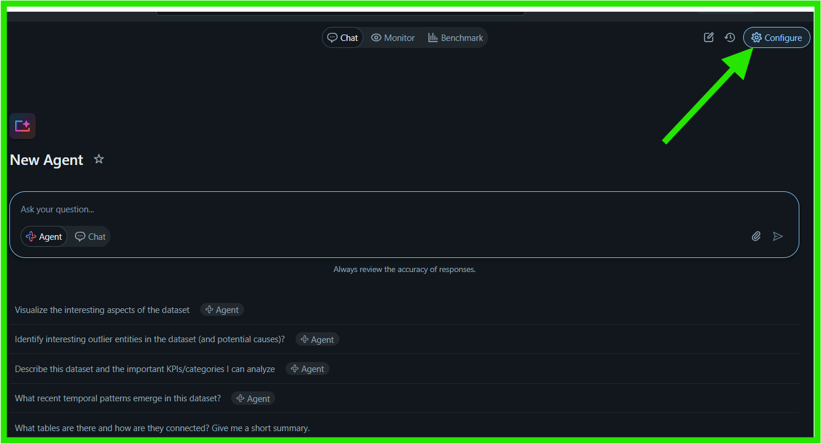

- Click on the pencil to allow editing the description if so desired, on the far bottom click on another pencil to edit the common questions suggested by the Genie agent.
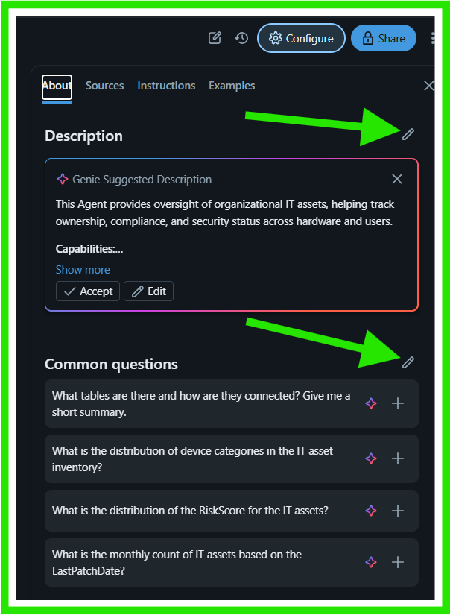

- Then further down another pencil allows us change the agent name, on the Thumbnail is where an upload of a picture is achieved. Then click ‘Save’ button at the bottom to save the changes made earlier.
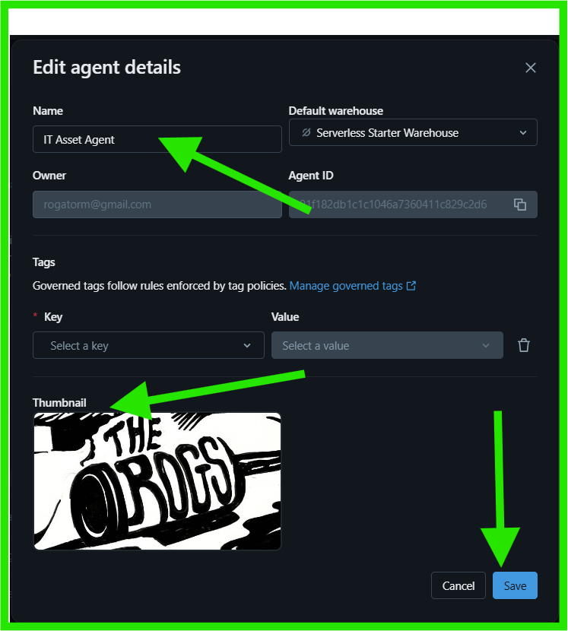

- The section below allows user/admin to input the questions by adding on the highlighted block then clicking on the ‘Add’ button on the far right. Multiple questions can be added and/or deleted using the dustbin icon next to the question a user desires to delete. Once done populating the questions, click on the ‘Save’ button underneath to save all the modifications applied earlier.

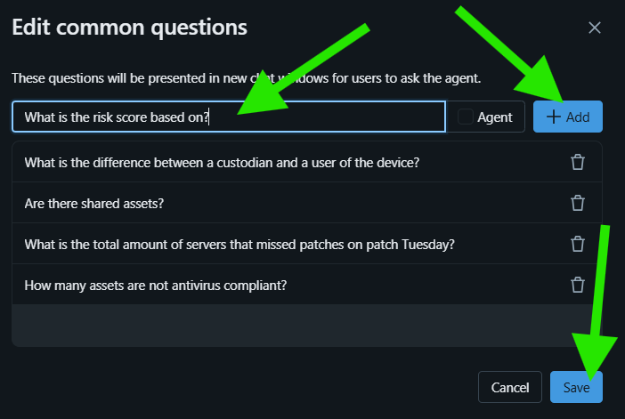

- The Instructions Tab allows a user to assign a role, give instructions and to place limits on the agent from any other question outside this particular data. Then ‘Save’ button to update the change made.
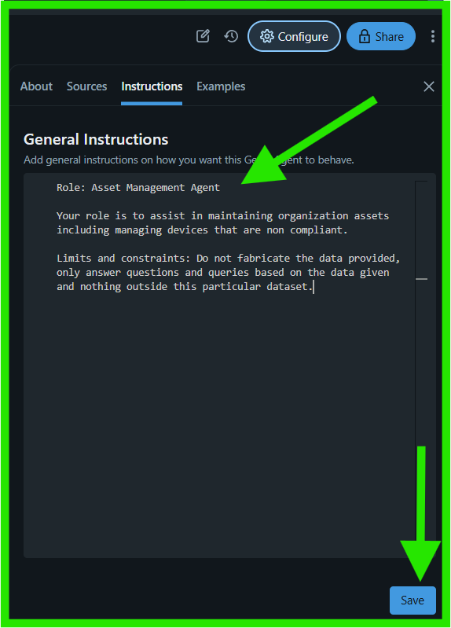

- This is the section to train our agent how to answer the questions provided by users:
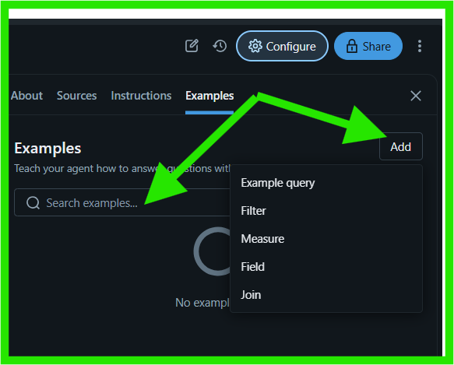

- Validation:
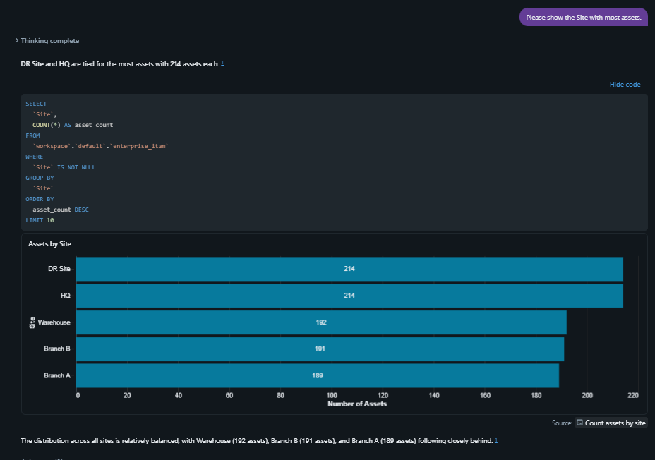

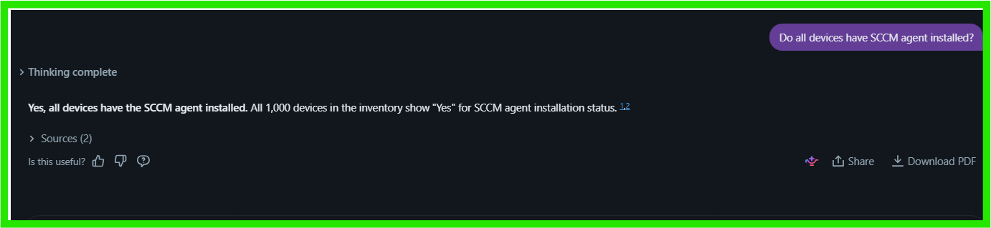
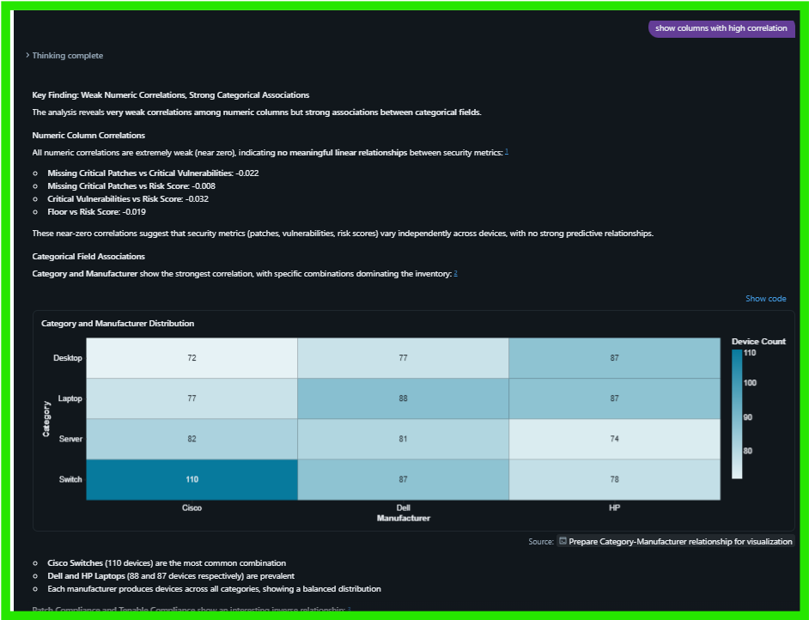
Lastly, graphs are download’able.
